Chapter 5 – Android Resources

**Chapter Objective**

* To know what is Android Resources and kinds of resources.
* Understand briefly how each resource works.

**What is Android Resources?**

* Resources: bundled to the app, stored in res/directory, can be accessed by code line: R.<category>.<resourceName>.
* Content: layouts, values, drawable, raw, style, design guidelines.

**Layout**

* **Definition**
* A way to organize Views inside an UI, can be created in XML files in res/layout, nested.
* **Layout XML**
* Containers (ViewGroups) contain Views (TextView, ImageView, EditText, Button, ImageButton,…).
* Required: layout_width, layout_height. Optional: id (findViewById()).
* **Adaptive: Layout on Android**
* Use different layouts XML in different directories. Eg: tablet: layout-large, layoutxlarge, …
* To load XML layout: In Activity file, use onCreate() with setContentView(); Fragment: use onCreateView().
* **Popular Layout classes**

FrameLayout, LinearLayout, RelativeLayout, ViewPager.

* FrameLayout: can contain multiple children, multiple layers, first child will be at the bottom, support child margins, gravity.
* LinearLayout: one direction, horizontal or vertical.
* RelativeLayout: enables to specify how child views are positioned “relative” to each other.
* ViewPager: a convenient way to supply and manage the lifecycle of each page.

**View Pager**

* **Create Viewpager**
* Horizontal swipe gesture, page by page scrolling.
* Each page tab is a fragment.
* How to create ViewPager?
* XML layout, add a short code.

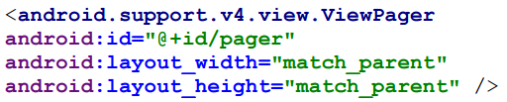

* ViewPager accessed through “Adapter” in Java class.
* Setup ViewPager in Activity’s onCreate().
* **Create Header for ViewPager:** use TabLayout.
* In XML file: add a short code.

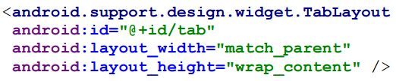

* In Activity/Fragment: setup a link.



**Values**

* **Types of values**
* String: res/string.xml



* Integers: res/integers.xml



* Booleans: res/bool.xml



* Colors: res/colors.xml



* Sizes: res/dimens.xml

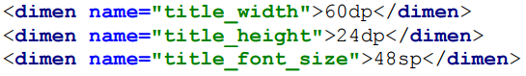

* Arrays: res/arrays.xml
* Themes/ Styles: res/styles.xml

**Drawables**

* 2 types:
* XML drawables: res/drawable.
* Bitmap drawable (PNG/JPEG): res/drawable-*dpi.
* ImageView: src=“drawable/name”.
* View: background=“drawable/name”.

9patch Drawables: *.9.png, transparent, stretch certain part of the image, padding.

**Raw Data:** embedded in apps, fonts, JSONs, audio, HTML/CSS/JS, etc.

* Place to store raw: res/raw or assets/.
* Raw is accessible with Context.getResources().

*How to use Raw data

* Use input stream to access binary data



* Use file name with Context.getAssets()



**Menu**

* **App Bar:** Navigation Drawer, App logo, Activity Title, Actions.

How to use App Bar

* Add ToolBar to the Activity layout.

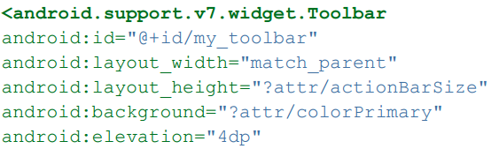



* Setup in onCreate(): add code.



* Define menu resources: defined in res/menu/weather_menu.xml.
* Inflate the menu:

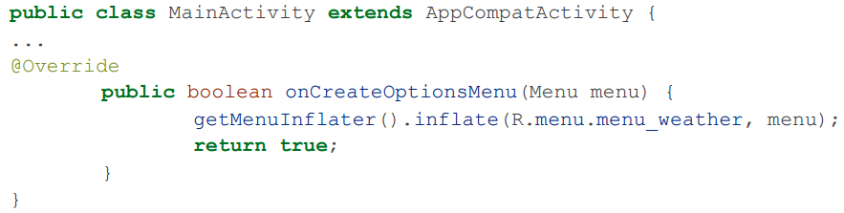

* Response to actions: override onOptionsItemSelected()

